|  |
| --- |
| **Church News**  radiYAte Weekend Away  Young adults weekend away is happening Sept 14-16! Our speaker is James Chen. Don’t miss out on early bird rates. Find out more on Facebook and register asap.  Missions Prayer Night  Join in prayer for Heidi, Carey and Azarlya as they prepare to go. Hear from them and pray for what lies ahead. We will also be lifting up the peoples of Central Asia in prayer. Thursday 14th June @ 7.30pm  FRESH in August  We’ll be running 5 weeks of supper and dialogue for our non-Christian friends starting August 8 in Kingsgrove. Think about whether you’d like to come and who you can invite.  Support Gospel work at SWEC!  Generous financial partners are needed to help grow the ministry of Gospel work at SWEC.  Please consider partnering with SWEC by setting up electronic giving.  For information on how to set this up, email [give@swec.org.au](mailto:give@swec.org.au)  Community Groups  Want to know how your faith in Jesus interacts with your everyday life? Community groups are a great place to help you think through this. Meeting throughout the week on a regular basis, community groups are a great opportunity to help make sense of what it means to be a believer of Jesus in this world. For more information please email [communitygroups@swec.org.au](mailto:community@swec.org.au) |

|  |  |  |  |  |  |  |  |
| --- | --- | --- | --- | --- | --- | --- | --- |
| **Upcoming Events**  June  14 – Prayer Night – Heidi and Carey (7.30pm Kingsgrove)  17 – Church lunch  July  1 – Compassion Sunday  18 – Combined Prayer and Worship Night (7.45pm Kingsgrove) | **Stay Connected**   |  |  | | --- | --- | |  | fb.com/swechurch | |  | @swechurch | |  | swec.org.au/newsletter | |

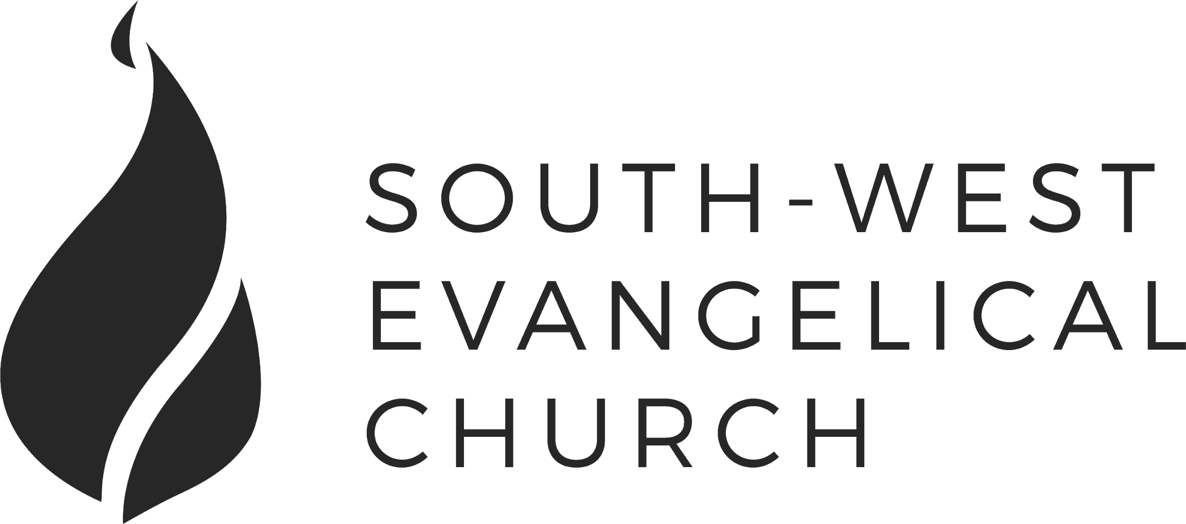

Sunday, 10 June 2018 | Kingsgrove 11am Service | [www.swec.org.au](http://www.swec.org.au)

Pastor Peter Ko | 0433 493 488 | pko@swec.org.au

What we’ll be doing during our time together

1. Worship

We’ll be worshipping God through song, prayer and by hearing His word.

Today’s confession prayer

Most merciful God,  
we humbly admit that we need your help.  
We confess that we have wandered from your way:  
We have done wrong, and we have failed to do what is right.  
You alone can save us.  
Have mercy on us:  
Wipe out our sins and teach us to forgive others.  
Bring forth in us the fruit of the Spirit  
That we may live as disciples of Christ.  
This we ask in the name of Jesus our Saviour.  
Amen.

Bible reading - Joshua 2:1, 8-14

2. Community

An opportunity to get updated with what’s happening at SWEC!

3. Prayer

We’ll be praying for various needs in our church, the wider community, and the world.

4. God’s Word

Today’s sermon will be given by Peter Ko.

5. Response

An opportunity for us to respond by singing, through holy communion, and by financial giving.

6. Blessing & Sending  
Go with God’s blessing to love and serve him and the world.

|  |  |  |
| --- | --- | --- |
| **Pastors**  Peter Ko (Lead Pastor)  Stephen Fei  Dom Cheung  Karen Ko | **Elders**  Johnson Lee  Andrew Lim  Kirby Wong  Nelson Siu  board@swec.org.au | **Student Pastors**  Andrew Hayes  James Hoey  **Ministry Intern**  Lisa Truong |

You Can't Stop The Blessing

Numbers 22-24

Introduction

1. The Story

a. Balak and Balaam

b. Balaam and Donkey

c. Balak and Balaam and God

2. The Message

a. The Enemy

b. The Twist

c. The Blessing

3. The Messiah

Today’s Sermon Code: S69

Zacpages is a digital church tool to follow our sermon outlines, read bible references, take notes and find out more information about our upcoming church events.

Check it out on the Apple App Store, or Google Play Store!

